Cori Scott

GE102-01

December 15, 2018

ETHNOGRAPHY PROJECT

#### INTRODUCTION

I am third-generation American. My mother’s grandparents all came here from Eastern Europe and my father’s grandparents came from Ireland and Scotland. My father’s parents both died when I was very young and the emigration story I know from any of them is my maternal grandfather’s, who was sent here from Ireland for his political stance and told to never return.

My mother’s grandparents came to America to escape the pogroms in the last years of the 19th century, all for the same reason but not at the same time. I grew up hearing stories of ‘Ellis Island names’, surrounded by eastern European accents and poorly hidden tattooed numbers on arms. For the majority of my life, emigration stories were synonymous with religious persecution and world wars. My ancestors came here for an American Dream that involved safety and security… the freedom to live.

This project affords me the ability – the excuse, really – to ask the question of a new generation of emigrants. What are the 20th and 21st century reasons for emigrating here? I wanted to learn about specific goals in coming to America, as opposed to any other country. I wanted to hear about their first impressions of the US and how that may differ from their expectations. I wanted to know how our country is seen from the outside, by people who didn’t grow up taking it for granted.

#### METHODOLOGY

I wanted to get people from very disparate backgrounds, with my ultimate goal being three people from three different continents, to compare and contrast their emigration stories and experiences. I met with each of my subjects face to face and recorded our sessions on my iPhone, then transcribed the recordings when I got home. I learned a lot from each person, things I didn’t expect. Secondary research into each origin country was conducted online, using various online reports, encyclopedias and economic resources.

#### FINDINGS

#### Brazil

Brazil is the largest country of South America, but sparsely populated. Its total current population estimate for 2018 is 211.6 million people, but its population density is only 62 people per square mile. The age-sex pyramid (see Appendix A) shows that the largest age group as of 2015 was in the 30-34 yo range, closely followed by the 15-19 yo range. Brazil is considered a ‘young country’, meaning the majority of its population is young. Even though Brazil is listed as a ‘newly industrializing country’, or NIC, it is home to the largest city in the southern Hemisphere – Sao Paulo, one of the world’s major industrial and commercial centers (EB).

Almost half of the entire population of Brazil is of white European decent, followed closely by Mulattoes (mixed European / African) and Mestizos (mixed European / Indian) which combined account for an additional two-fifths of the people. The main religion of the country is Roman Catholic, with roughly two-thirds of the population as adherents. The primary spoken language is Portuguese, although Brazilian Portuguese is to the original language what American English is to original English – it bears a resemblance but has changed and adapted many times over the years.

Some of the major issues facing the people of Brazil today include gang violence, police / political corruption, and the chronic violations of the rights of its indigenous peoples (HRW). That is not to say these are the only issues, but they speak to my interview with Lucy, who emigrated here from Valinhos, Sao Paulo.

Lucy comes from a large family, which she left school to clean up after and care for full time – a sort of second mother. A few of Lucy’s brothers were killed as a result of their ties to criminal gangs in the area. She tells me this is a common enough situation in her home country that people don’t grieve the same as we do in America. It’s sad, but not a total devastation.

Lucy came to America when she was twenty-two years old. Some of her female cousins told her there was work for her like what she did at home, but with pay. They told her American men like Brazilian women and she would find a husband and be taken care of. She thought of the United States as ‘the wild west’, believing all Americans carry guns and are ‘big bullies’, but to her that was nothing new and at least she’d have money for her family, so she agreed to come.

Today she runs her own house-cleaning business with a few cousins, a sister-in-law and an aunt. She has loyal, regular customers and even met her husband – just like her female cousins told her she would, though she swears it ‘wasn’t like that’, that her husband is a good man and hard worker. He even tries to speak to her in Portuguese, but she confides in a whisper “he butchers my language!”

Lucy’s American Dream was one of security… both physical and financial. A safe place to live without fear of the criminal gangs, where locking your door at night means everything will be okay, and money to sustain herself while still sending home enough to keep her family going.

#### Nepal

Nepal is one of the least developed, poorest nations in the world, due in large part to ongoing political upheaval (BTI). Nepal imports their basic, essential commodities and relies on foreign aid for the funding of the government’s failing development programs. Health care is inadequate, leaving the majority of Nepalis to rely on Ayurvedic medicine for their health needs.

The current Nepali population is estimated at around 29.8 million people, with a population density of about 77 people per square mile. The age-sex pyramid (See Appendix B) shows the largest age groups are all under the age of 15, and the average life expectancy is around 70 for men and 74 for women.

The major ethnicities in Nepal are the Pahari, the Tharu and the Newar. Pahari and Tharu are both Indo-European derived, and Newar combines Tibeto-Burman language and Indian social and religious customs. The official language of the country is Nepali, which derives from Sanskrit. 81% of the Nepali population follows the Hindu religious traditions (EB). There is one single urban area in all of Nepal – Kathmandu. The rest of the country is settled as small villages and market centers.

Nepal has a lot to overcome. Extreme political instability leaves the majority of the Nepalese without a means of any kind of economic development, with little to no access to adequate health care, and with significant systemic socioeconomic discrimination. Interestingly, with the exception of a single event, Nabin – my interviewee from Nepal – was largely unaffected by all of these issues before emigrating from Hetauda.

Nabin grew up in a relatively middle-class environment outside of the Kathmandu Valley. He considers himself lucky in that he had access to clean drinking water and good schools. Aside from gang violence and drug and alcohol abuse, he remembers no real adversity in his childhood and teen years. He does, however, remember one instance of upheaval in his younger years. He was out playing with his brother when they heard gunshots in the distance. His mother came outside screaming for them to get back in the house. She was terrified, but Nabin says he and his brother shrugged it off as unimportant. Apparently, this was during one of Nepal’s many political uprisings.

Nabin claims he did not originally want to emigrate. He had been offered a Teaching Assistant position at the State University of New York-Albany campus, but he was happy at home, with a ‘good life’. He says his friends kept pestering him that ‘all the good people go to the USA’ – meaning successful people. They intimated that he would have no choice if he truly wanted to advance in his chosen field, Physics. It was his love for physics and for teaching that ultimately made his decision for him.

He remembers flying over the Statue of Liberty as his plane was descending at Newark Airport, and pressing his nose to the window to get a good look. He had seen many pictures of the statue over the years but seeing it ‘in person’ that first time was very exciting.

A funny story he tells about acclimating to his new environment has to do with snow. Being Nepalese, everyone in America assumes he came from the mountains. He says no, he was born and raised on the far side of the valley. He could see the mountains but had never been. As a result, his first ever experience with snow happened in Albany, New York. He was hard at work at the university with his colleagues and looked up to see snow falling outside the window. He dropped everything and ran outside to stand in the middle of the street, head thrown back and arms extended to the sky. His colleagues all thought he was insane.

The only real misperceptions he faced as an immigrant were due to his skin color, and the aforesaid assumptions regarding mountains. Most people assumed he was Indian ‘because I’m brown’ he says, pinching the skin on his forearm. One person thought he was Burmese, which he thinks is hysterical but will not say why. ‘Mostly, I’m blind to it. I think, being a geek, it helps.’ he explains about experiencing racism. Apparently, he only knew if someone else pointed it out to him afterward. He said he felt bad for those people, because they only affected themselves.

His lifelong goal of winning the Nobel prize is a work in progress, according to Nabin. He says that this was a big part of coming to America – upping his chances. In the meantime, he couldn’t be happier. He gets to teach.

#### Russia

Russia is industrialized, but more an oligarchy than truly capitalist. Due to its bullying political tactics, trade sanctions are imposed on Russia with a fair amount of regularity. The country is still having issues throwing off the dictates of their former economic structure.

Russia’s current population estimate is near 143.96 million people, but their population density is only 22 people per square mile, making it one of the least densely populated countries in the world. It is also one of very few countries with a negative population growth rate (WPR). The age-sex pyramid (See Appendix B) shows that the largest demographic range in age from 25 to 34. It also skews slightly toward the females in the sex ratio. Of note is the lack of numbers under the ‘no education’ category.

81% of the total population identifies as Ethnic Russian, with the next largest percentage being Tartar. The primary spoken language is an east Slavic Russian, though there are over 35 other languages designated as ‘official’ and hundreds more that have no official recognition (WPR). The dominant religion practiced is Eastern Orthodox Christianity.

Russia seems to have trouble ending their bullying tactics. Trade tensions stemming from their ongoing disputes with Ukraine and Crime have so far prevented the country from achieving its potential in terms of global growth. Oil production hit an all-time high in 2018 (WB) despite Russia’s signing of the Paris agreement. Certainly, these are important issues, but they bear almost no resemblance to the Russia that Alla left behind when she emigrated.

Alla remembers the exact date she came to America: November 30, 1993. Still the USSR at that time, even still it was a tough decision to make. She and her husband were both successful with good jobs, a rarity in that time and place. Ultimately, they chose to leave behind the instability and lack of freedom – the closed borders and start again somewhere more open. Her husband’s brother had already emigrated to Massachusetts and offered to help them get settled and establish their new lives.

Alla tells a disturbing story about a summer trip she and a friend wanted to take to Bulgaria as students. They were ‘asked’ to come and explain to the KGB their desire to leave the Russia. She remembers feeling surprised, though expresses that she shouldn’t have been. ‘Traveling abroad was the communist elite prerogative.’ They were informed that there were plenty of places they could go within Russia and denied permission to go. She tells me they wouldn’t have dared try to sneak out, since ‘there were KGB informants at all the colleges’.

This scenario plays out like a scene from a book or movie in my head, because I don’t have a single relatable experience. I could never dream of being denied my freedom of movement for any reason, much less for no reason at all. Alla tells me that she and her husband had high hopes for Russia under Gorbachev, believing that positive change was imminent – and of the resulting deflation of their hopes when no change was forthcoming. They were told that Alla’s husband held ‘secret information’ due to his job as an aviation engineer, and as such could not be permitted to leave Russia. She tells me they became ‘refuseniks’, a term used to describe people in soviet Russia who were ‘refused’ permission to emigrate outside the Eastern Bloc.

Starting over after finally reaching the US was hard, because their college degrees were meaningless here. They literally had to start from scratch. Because she spoke English, Alla was able to get a job early on. She ended up with three jobs, working 7 days a week to support her family until her husband finally found work as a laborer. Their hard work ensured better opportunities for their daughter, who is now an optometrist at Harvard University.

Alla refuses to complain. She will not tolerate a single word said against America. She has found the one thing she sought here, freedom. She can move about, vote, and speak her mind without fear. Alla and her family are living their American Dream.

#### RESULTS

Reading back through all that I’ve written, I can see similarities and disparities in these stories. Each of my interviewees had their own particular version of the American Dream. Lucy came seeking security, and in the process found a career she is proud of and a husband she loves. Nabin came for the opportunity for advancement and found his true calling. Alla came for freedom and found it, in every aspect it entails. The biggest, most glaring disparities in these experiences are more in the lives being left behind.

#### CONCLUSION

I think it’s safe to say the American Dream is alive and well. It’s just a bit different than the original version. I think each of the people who helped me with this paper experienced their version of the American Dream without even realizing it… at first, anyway. What I mean is, they didn’t even know they had this dream until after they’d arrived here and begun their new lives. Maybe it’s just how easy we Americans have it, compared to other countries. We do tend to take our freedoms for granted. It defies articulation, the feeling I got as I witnessed another human being achieving the opportunity to *not* take it for granted.

#### APPENDICES

Appendix A: Brazil

1. What is your native city, state/region & country?

Valinhos, in Sao Paulo. Small city compared to others but still big. Lots of people. Lots of business. Big business, lots of workers. Medical and school, but also poor. Lots of poor.

1. What was life like for you back home? School / Work / Home life?

Loud, lots of people. Busy. There is school, but not everyone goes. Some stay home to help the family. Only go to school to be doctors or that. Not like here. Home was loud. I have big family. Lots to help. Lots to do. Always busy.

1. What kind of adversity / conflicts did you witness or face?

Crime not like other places in Brazil, but still there was crime. My brothers, some of my brothers worked for crime… criminals. My brother died, was killed. It happens, is like common. Gangs. They fight, kill each other.

1. What made you decide to come to the United States? How old were you when you arrived?

(Laughs) not sure I should tell! My cousins, they come. They say there is work, it is safe. They say men here, American men, like us women. They say men here will marry, take care. They say I should come, meet husband. I come to work, to get money for my family. I did get married (laughs), but not like that. He is good man. I work. work hard, get money, give to family. Twenty-two, when I came. I go home, few years, come back. I give money and gifts for family.

1. What were your very first impressions of the United States when you arrived?

In Brazil, America is wild west (laughs). Everyone has a gun. Everyone is armed. We think America is tough. Big bullies (laughs). I get here, is not like that.

1. What are some differences between living in the United States and living back home?

Is safe here. Here, you lock your doors, you’re safe. Here, not as loud. Busy, but not loud. People here are funny. Work a lot for money, for things. Not hard work. Hard work is for poor people, right? Here people work long, but not hard.

1. What kinds of things did you struggle with getting used to?

Driving! Here you drive everywhere! Everything so far! People here drive crazy (laughs).

1. What are some ways that people have had misconceptions or misperceptions about you?

People think I’m Mexican, Puerto Rican, Indian. People yell at me to go back to Mexico (laughs).

1. What made you decide to pursue your chosen field of work?

I work hard at home, to help. I clean. Here, I get money to clean. Is easier here. Lots of us to clean together, get good money. Men are nice, when you clean for them. They… appreciate, yes?

1. In what ways have you achieved or not achieved your goals in the United States?

Here I am safe. I can work, get money, and can sleep well. I get money for my family, so yes. I achieve (smiles).

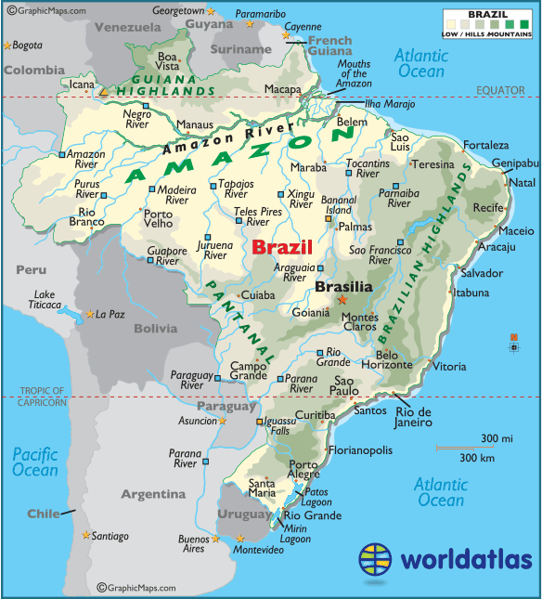

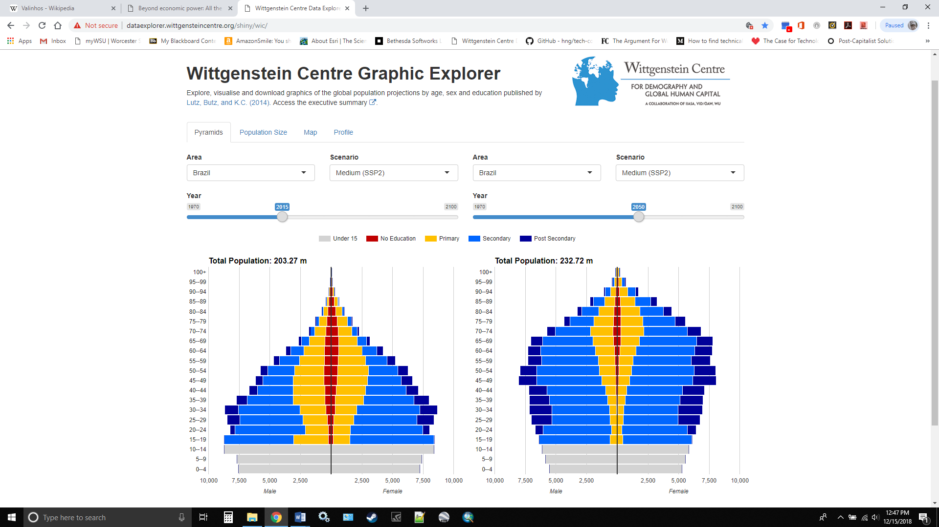

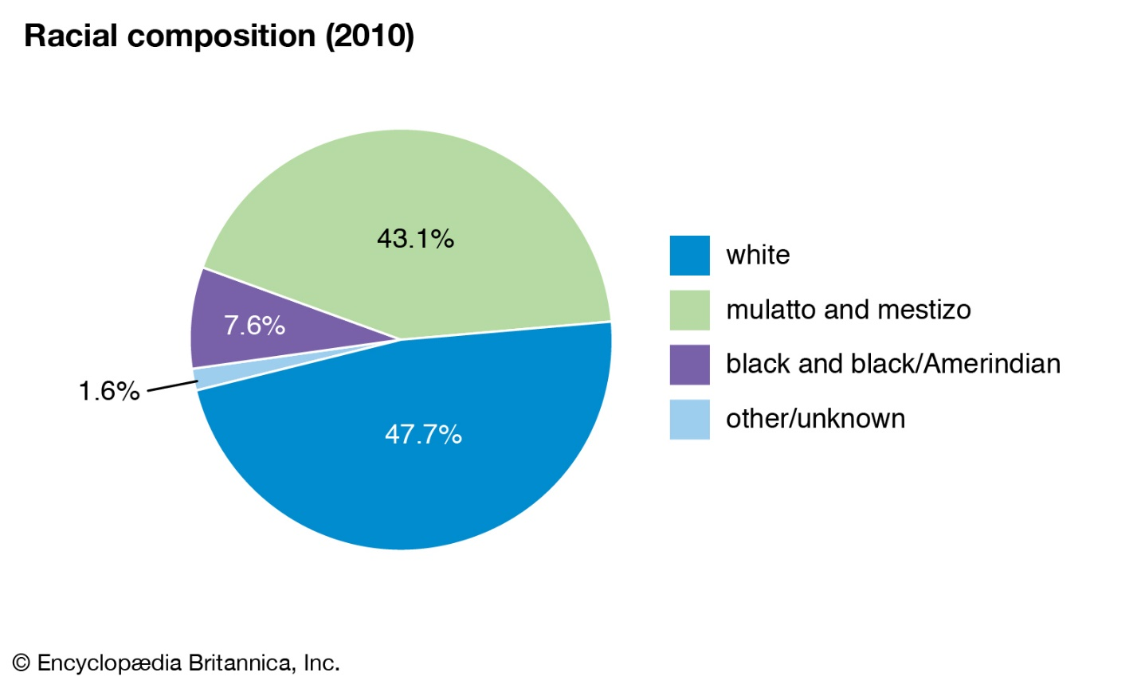

Appendix B: Nepal

1. What is your native city, state/region & country?

I was born outside the Kathmandu Valley. The country is Nepal. It’s about 100 km south of Kathmandu. The city is called Hetauda.

1. What was life like for you back home? School / Work / Home life?

I was one of the lucky ones to be in the semi-suburb types of area, so life was good in a sense. I had access to clean drinking water, good school, good shelter. I was, like, middle class. So, life was good. I mean for growing up in third-world country, what would you expect?

1. What kind of adversity / conflicts did you witness or face?

My city was still booming at that time, so there were problems like teenagers getting into drugs and gang fights, but as far as larger conflicts I kind of had that blessing when I was growing up that I did not see that happening. Lucky. But outside that city, there was political conflict sometimes. I remember there was a political uprising when I was younger, and I could hear the gunshots far away but didn’t directly witness it. We were kids, you know? We’d go outside to play, and my mother was terrified telling me to get back in the house, but I didn’t really understand.

1. What made you decide to come to the United States? How old were you when you arrived?

Physics. My love of physics. Initially I did not want to go, you know? I was like, come on, life is good. But my friends were like ‘good people go to USA’ (laughs). So yeah, love for physics and love for teaching. You know it’s like ‘you get to be TA, you get good money, and then you get the degree of your choice’.

1. What were your very first impressions of the United States when you arrived?

It’s different than New York City that we had been seeing in the movies, in the documentaries, you know? So, first impression was like ‘huh!’. It was a bit of culture shock. We landed at Newark airport, so we did see that Statue of Liberty from the window and were excited. I had been seeing pictures of the Statue of Liberty for a long time, it’s like the symbol of the USA, and I got to see that from the airplane. But then we landed, and I was like ‘hmm’. Not what I was expecting (laughs).

1. What are some differences between living in the United States and living back home?

There were natural resources where I lived, right? But not well-managed. So, we did not have 24-hour flowing water. We did not have the gas stove. Most of my life I ate from the stove that was burning wood. The temperature is about the same, but we did not get that cold. It would go from about 0° to 30° C.

1. What kinds of things did you struggle with getting used to?

I was mostly in it for the academics, you know? So, I did not have this real-life experience with the real world until much later. Thankfully I had friends who helped me assimilate in a sort of way, you know? Like help me get familiar with the culture. But I did not get into interacting with other people a lot, so there was not a lot of culture. But there was culture shock, obviously. You know, it’s funny. When I moved from one part of the USA to the other part of the USA (from New York to California) there was more culture shock there than when I came from Nepal to USA.

1. What are some ways that people have had misconceptions or misperceptions about you?

People assume that I come from big mountains. I could see the mountain, the beautiful snow up there, but never went there. People think that I’m Indian sometimes because of my skin color, you know? People can be like ‘you’re not really Indian because they have bigger eyes’. People think I’m from Burma, or Thailand. Mostly, I’m blind to it. Somehow, I don’t get it. Being a physicist, and geek, I think helps. Like I talk at that brain level. Like, I have an idea… you have an idea. That’s it. Then after I just disconnect from it. It’s over, you know?

1. What made you decide to pursue your chosen field of work?

Growing up, I had this curiosity of how things work around you. During high school, I realized this science topic was interesting because it helps you to estimate, calculate and predict whatever is going on out there and you would do the experiment and get the same result. So, that is like… magic, and being able to do the magic or understand what is happening inside the magic is fun.

1. In what ways have you achieved or not achieved your goals in the United States?

There is a Nobel prize that I have not achieved (laughs). You know, my dad used to bless me with, like, a quest to get a Nobel prize, right? And I did not get it. Yet (laughs). I have achieved the knowledge I was looking for; I have achieved my quest for working in a place that I wanted to, that was a dream; I have achieved a degree; but it’s a work in progress, yes?

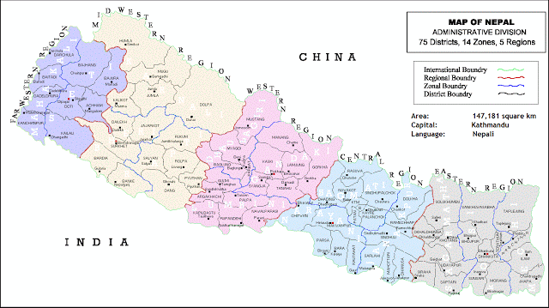

Source: We All Nepali, http://www.weallnepali.com/about-nepal/map-of-nepal

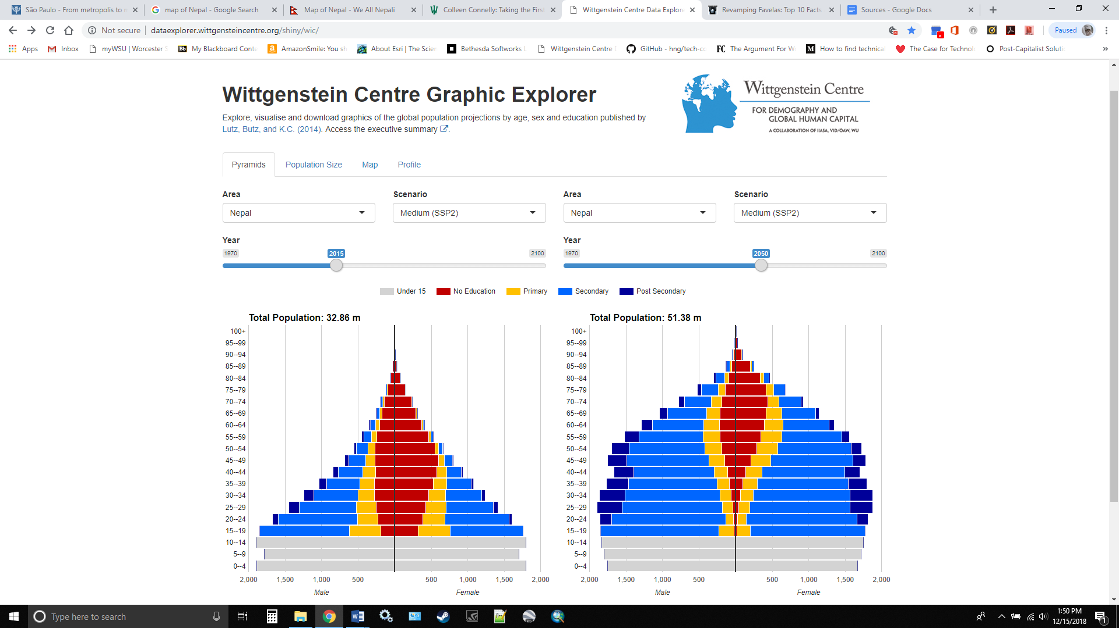

Appendix C: Russia

1. What is your native city, state/region & country?

I am from Kazan, the central part of Russia. The city is located on the Volga river.

1. What was life like for you back home? School / Work / Home life?

School in Russia differs from the one here: we have Elementary school, from Grade 1 to Grade 3, and Middle school and High school combined. I used to be a teacher of a “Combined” school. I taught the kids at the age of 9-10 until their graduation, age 16 or 17. I loved my job. At some point, I became a vice-president of the College of Commerce. At the age of 23 I got married. My husband was an Aviation engineer. 25 years ago, on November 30, 1993, we emigrated to the USA, my husband, our 16-year-old daughter and myself. It was a tough decision. My husband and I were both successful and had good jobs.

1. What kind of adversity / conflicts did you witness or face?

It was the USSR that we left. We hated their hypocritical ideology, lack of democracy, lack of freedom, unpredictable life, closed borders. I remember when I was a student, my friend and I wanted to go to Bulgaria for a summer break. We were asked to come to a KGB, they asked questions why we wanted to go there – to Bulgaria! Also, socialist country. As a result, we were not allowed to go there. They said there were a lot of other places in Russia that we could visit. Travelling abroad was the communist elite prerogative. Also, we knew that there were the KGB informants at every college.

During Gorbachev’s times, we had a hope that we would be able to leave the country. But nothing changed for us. We were not allowed to leave because of so called “secret information” that my husband knew. We became “refuseniks”. We had to wait. Our dream was to live in a free world, to be able to express our point of view without fear to be prosecuted or lose a job.

1. What made you decide to come to the United States? How old were you when you arrived?

I was 40. We left the country at the time of the war between criminal gangs in our city. Recently, I watched the movie about that war. Why the United States? My husband had a brother who lived in Brookline, MA. So, we came here.

1. What were your very first impressions of the United States when you arrived?

It was hard. We had to start from scratch. Our Russian authorities did not allow us to sell our condo. We left everything there. But I spoke English, so I got three jobs, 7 days/week, until my husband got a job. Eventually, we stood on our two feet. My husband worked here as a worker, he is a retiree now. Our daughter works at Harvard University, she is an optometrist. And I ended up as a QA Engineer.

1. What are some differences between living in the United States and living back home?

Day and night. We travel, we vote, we are free here. We work and are adequately compensated for that.

1. What kinds of things did you struggle with getting used to?

I am old-fashioned, I voted against selling marijuana in Massachusetts. I still think this is a mistake. “Benign” narcotic can lead to not-so-benign. How can you fight drug addiction and sell the drugs at the same time?

1. What are some ways that people have had misconceptions or misperceptions about you?

I have been lucky enough not to have experienced anything like that here. I thought maybe, when we first came, because of the Cold War and communism people would be hostile. But no, nothing like that.

I have seen people react to hearing my name, since after 9/11. Alla is common where I lived, so I was surprised at first, but I can see when people hear it they react.

1. What made you decide to pursue your chosen field of work?

I have two diplomas from Russia: Master’s in education and Nurse. None of them is valid here. In the beginning, I worked as a receptionist at a computer school in Brighton, MA. The owner of that school offered me to take free programming and QA classes. This is how I became a QA engineer.

1. In what ways have you achieved or not achieved your goals in the United States?

We were lucky, thank G-d. We achieved our goals. We live and work in a country that became our home.

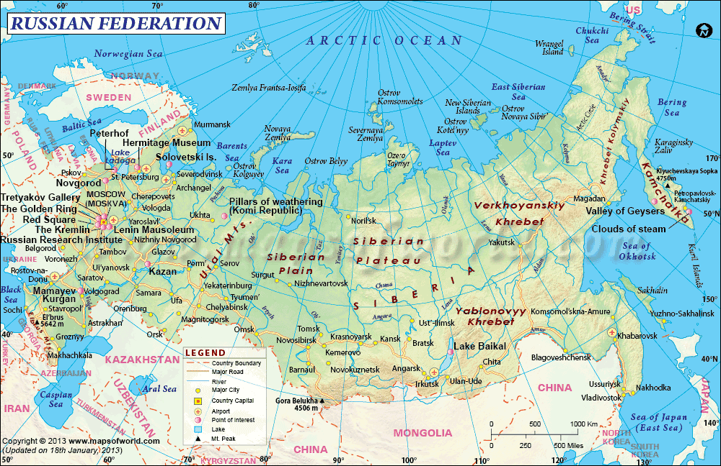

Source: Maps of World, Russia, https://www.mapsofworld.com/russia/

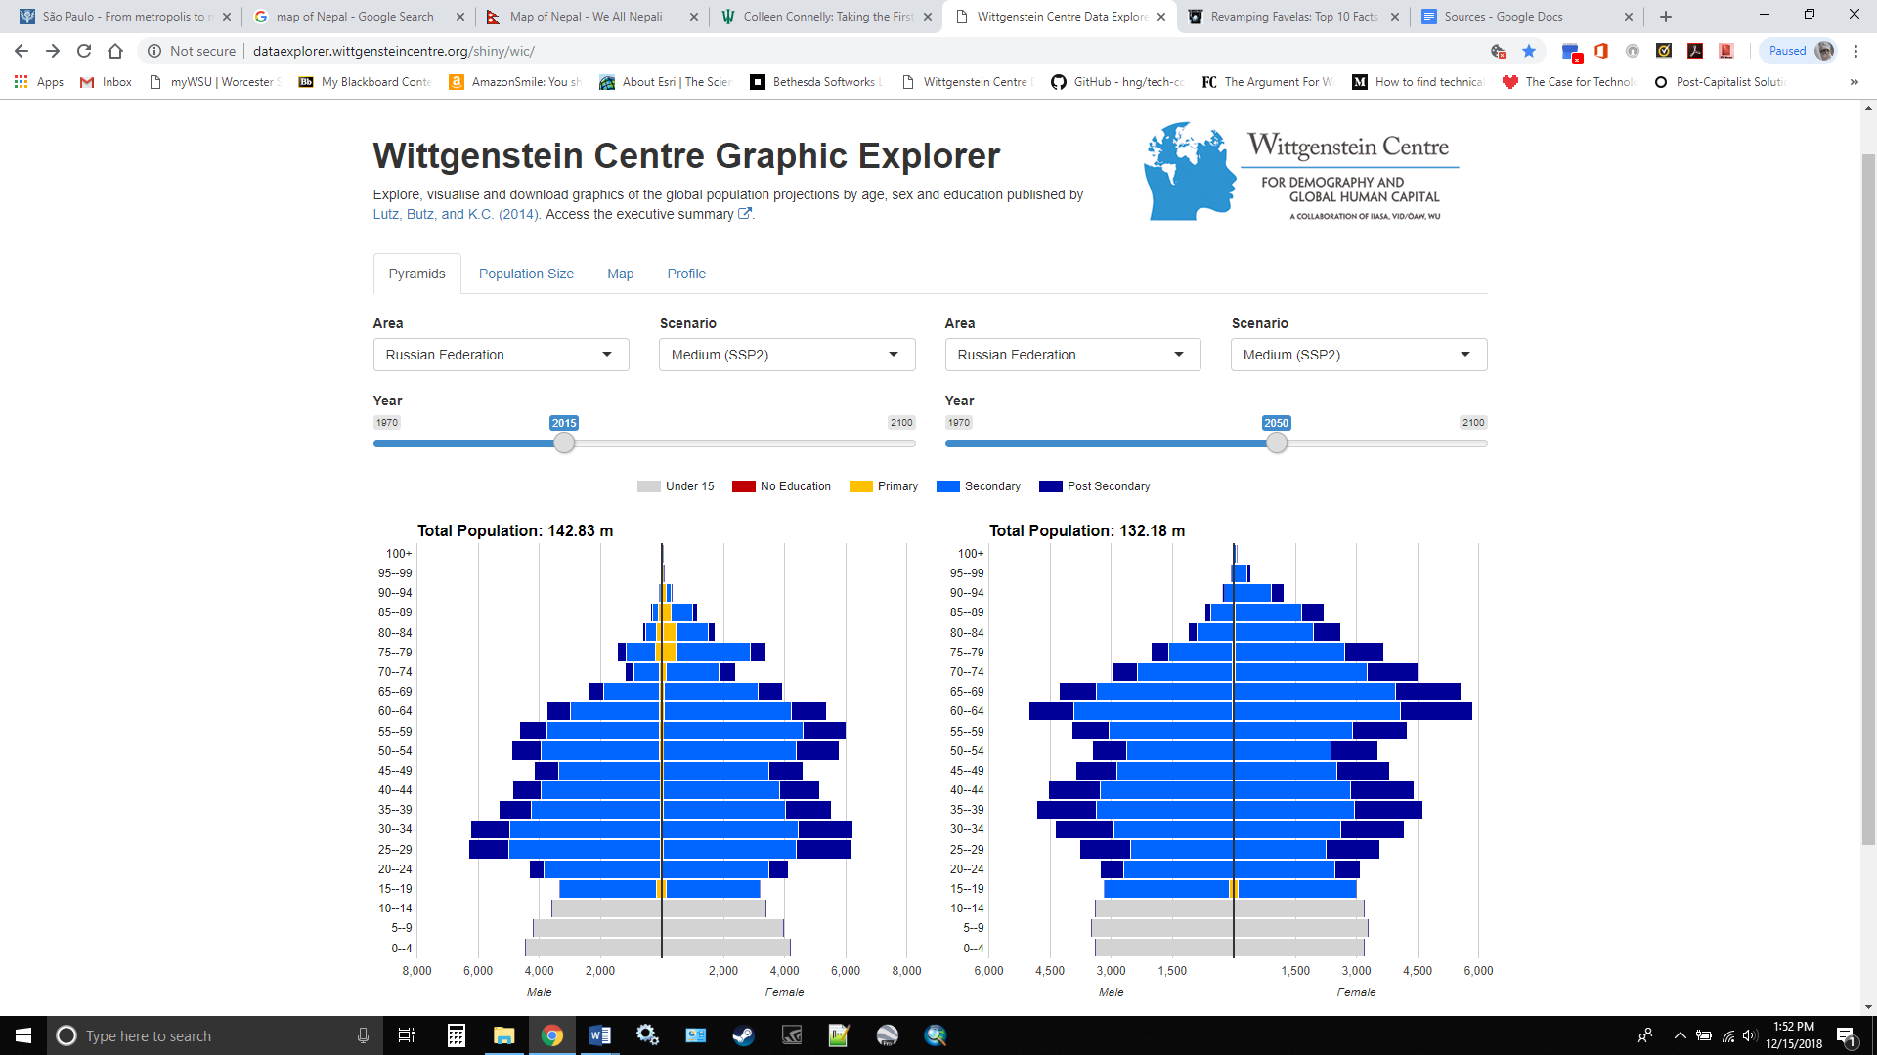

Appendix D: Sources

**WC. Graphic Explorer, *Wittgenstein Centre for Demography and Global Human Capital***

<http://dataexplorer.wittgensteincentre.org/shiny/wic/>

**EB. *Encyclopedia Britannica***

<https://www.britannica.com/>

**WPR. Total Population by Country 2018, *World Population Review***

<http://worldpopulationreview.com/countries/>

**HRW.  Brazil, Events of 2017, World Report 2018, *Human Rights Watch***

<https://www.hrw.org/world-report/2018/country-chapters/brazil>

**BTI. Nepal Country Report, BTI 2018, *Bertelsmann Stiftung Transformation Index***

<https://www.bti-project.org/de/berichte/laenderberichte/detail/itc/NPL/>

**WB. Russia Economic Report, *The World Bank***

<http://www.worldbank.org/en/country/russia/publication/rer>